**ASSIGNMENT 4**

**Ajax and Registration**

**Assignment Objectives :**

* **HTML5 features - Registration screen and Password strength**
* **AJAX - Utilizing AJAX for making the requests to server**
* **NodeJs server - A simple NodeJs server communicating with the MongoDb database**
* **MongoDb - Database for storing the user registration data**

**1. Registration Screen**

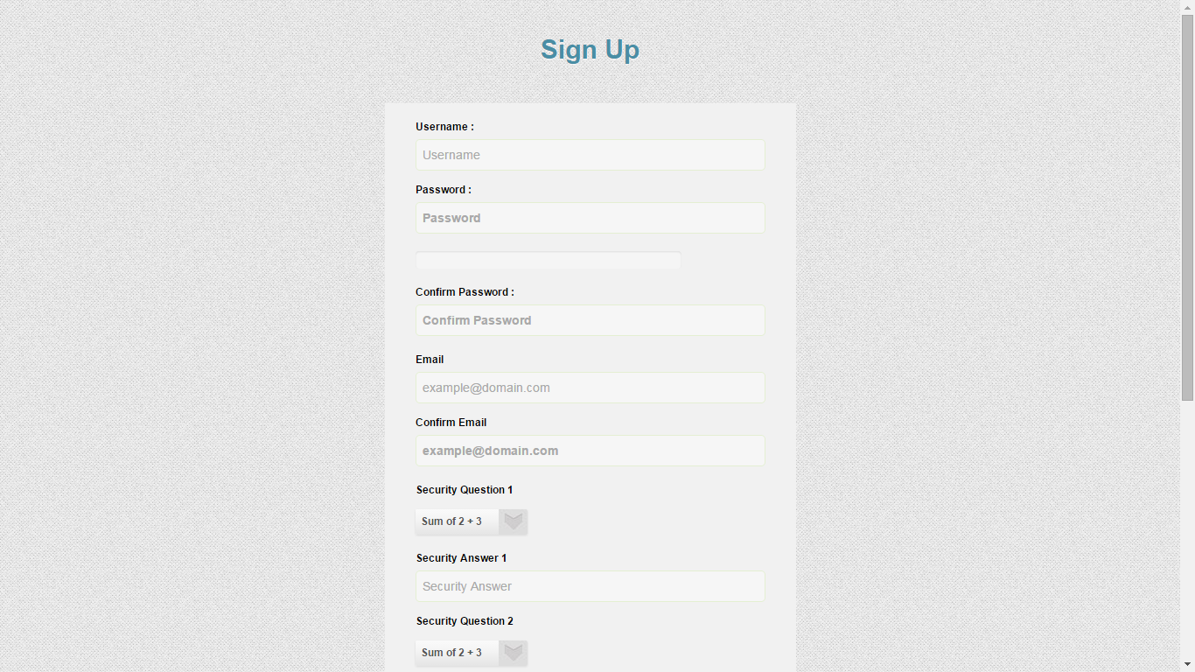

**2. Password strength ( progress bar)**

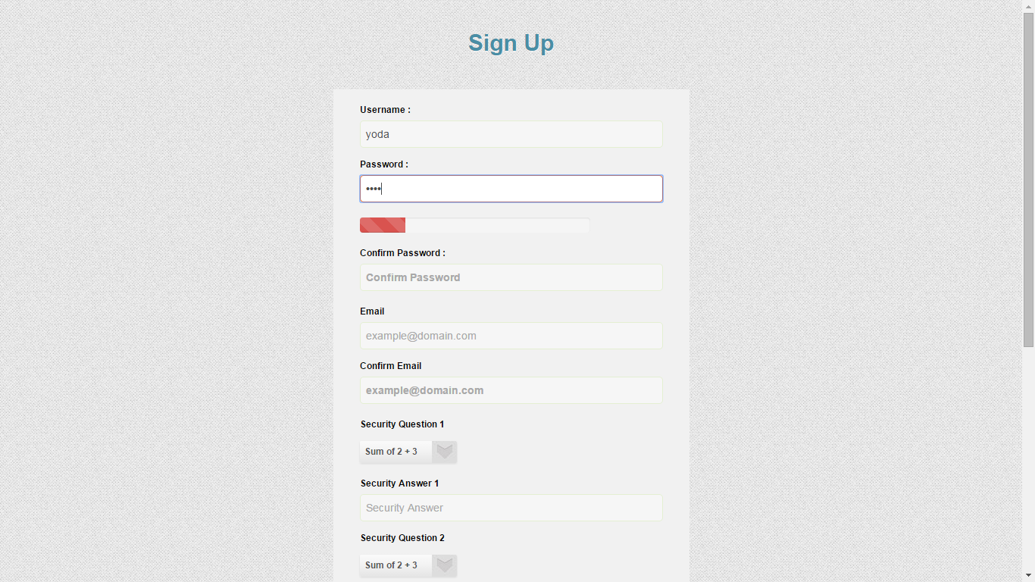

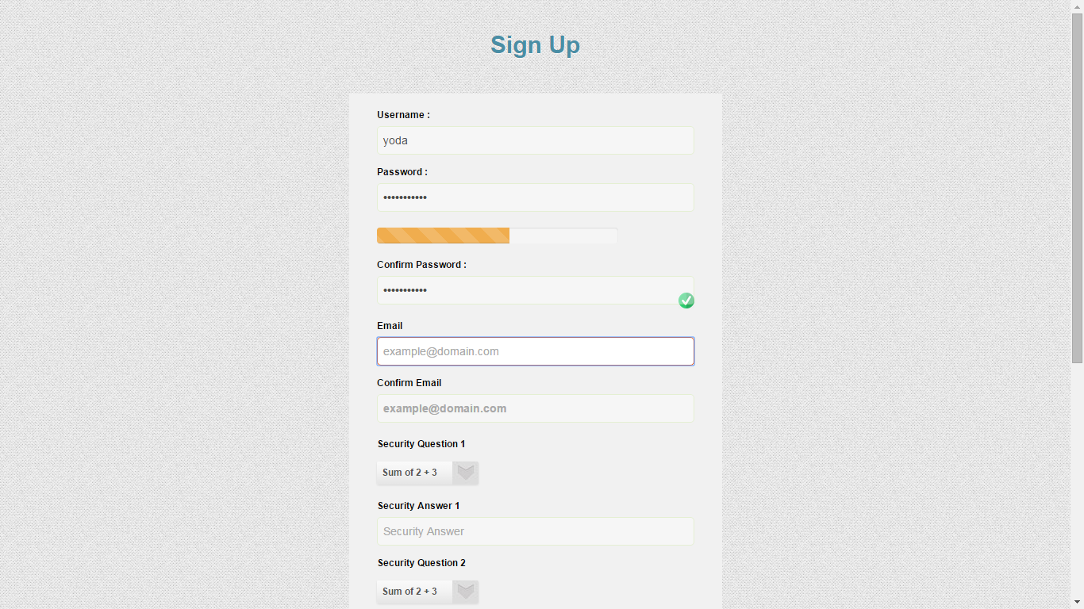

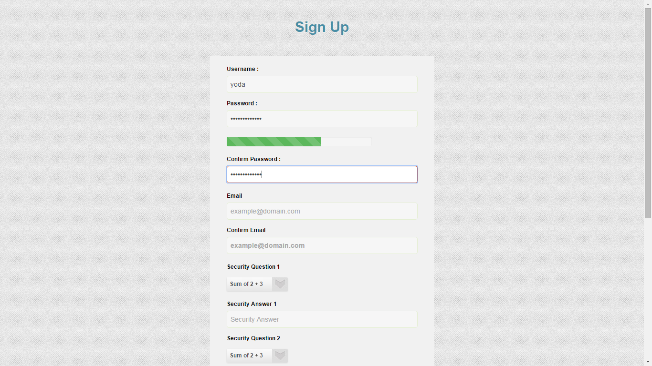

**3. Password match, E-Mail Match and Phone number validation (custom validations)**

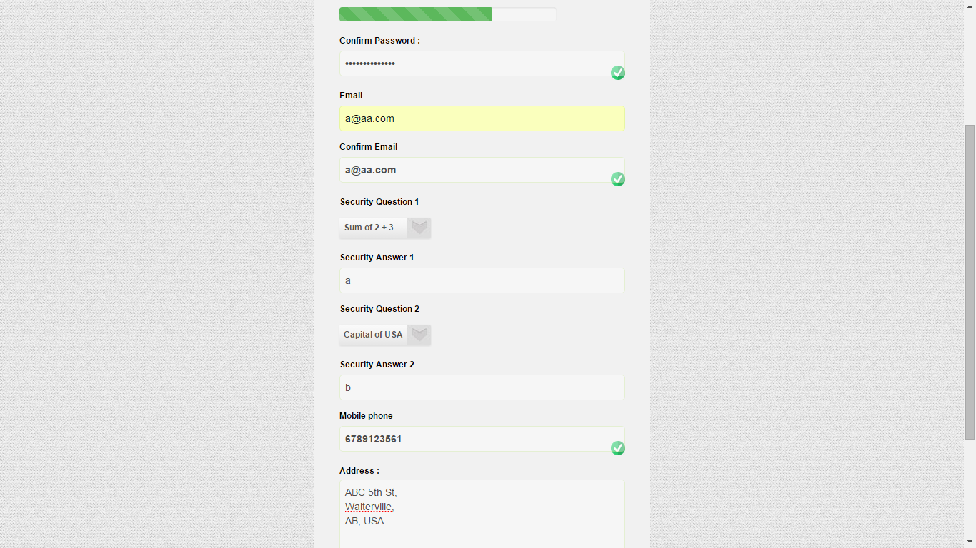

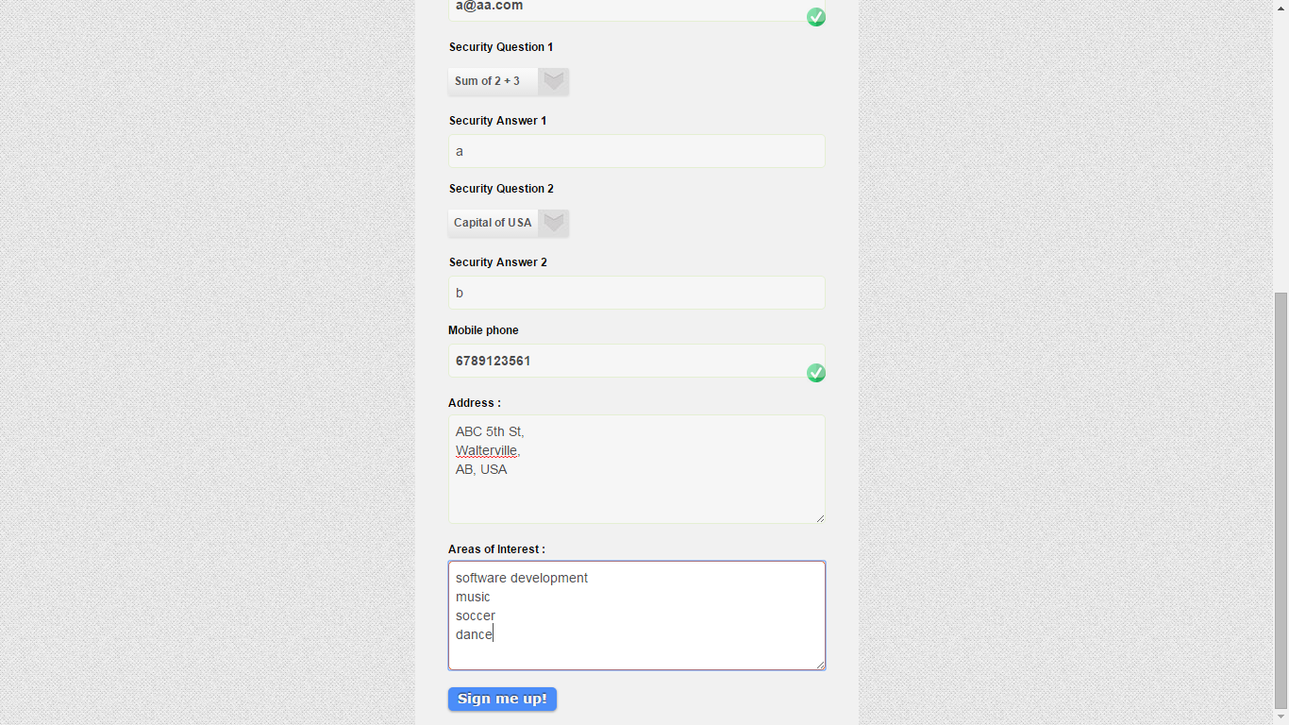

**4. Registration successful data saved in session storage**

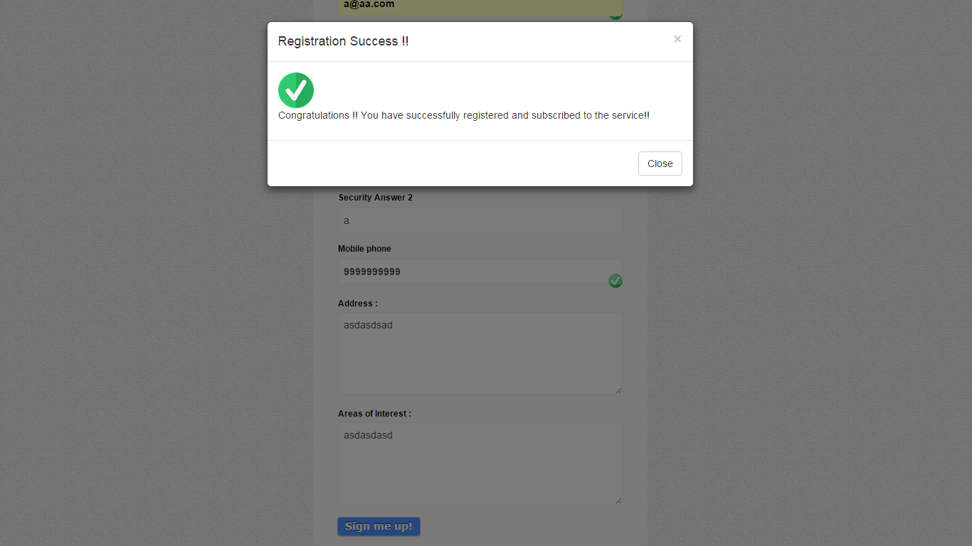

**5. Registration failure**

